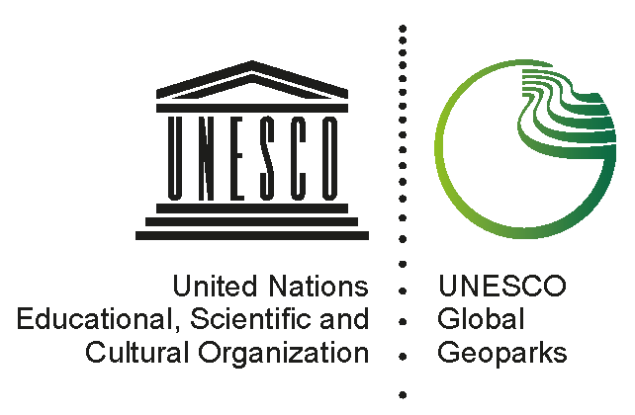 | Applicant UNESCO Global Geopark  name, country  geographical and geological summary

Please replace the map below with a map of your region, using a standard UN map showing the location of the aspiring UNESCO Global Geopark as shown in this example.
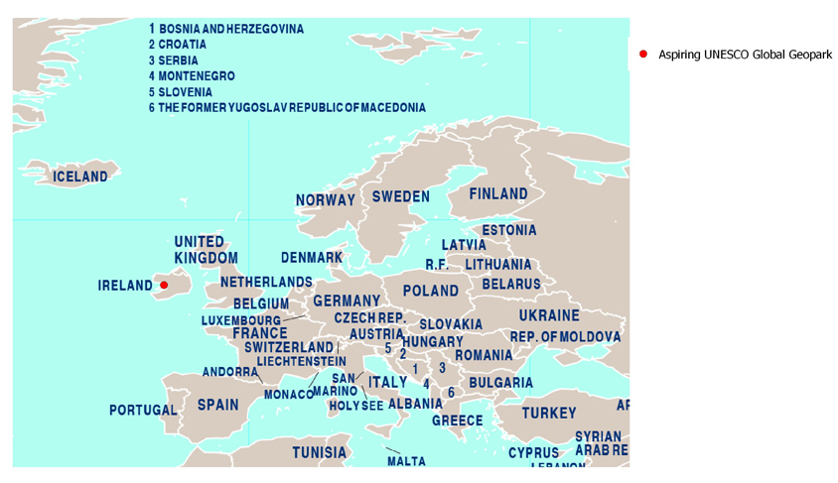
Please replace the map below with a map of the aspiring UNESCO Global Geopark indicating the boundary, cities, general geographic points, as shown in this example.
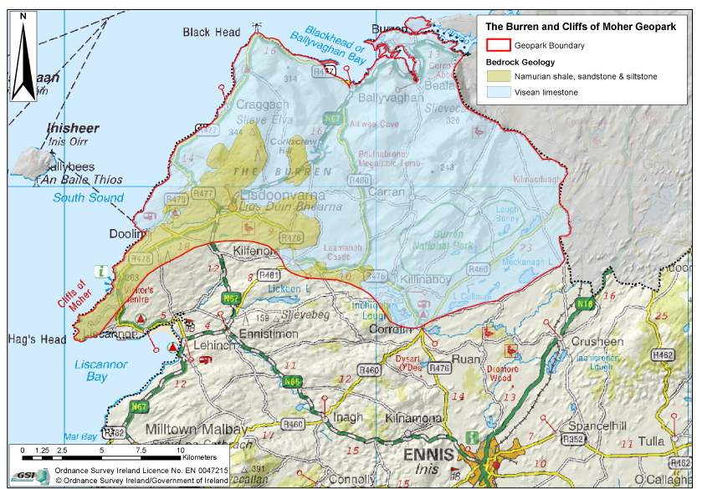

1. Physical and human geography- 1500 characters

Including for example: location, geographical coordinates, surface area, distance to main cities/to the border, landscape, relief type (mountain, plains, valleys, caves…), maximum and minimum elevation, climate, nature, administrative region and country, number of inhabitants, economic activity, settlements, infrastructure, etc.

2. Geological features and geology of international significance – 1500 characters

